Step 1: Install ChustaSoft.Tools.SecureConfig

Step 2: Setup a 32 hexadecimal character private key

Step 3: 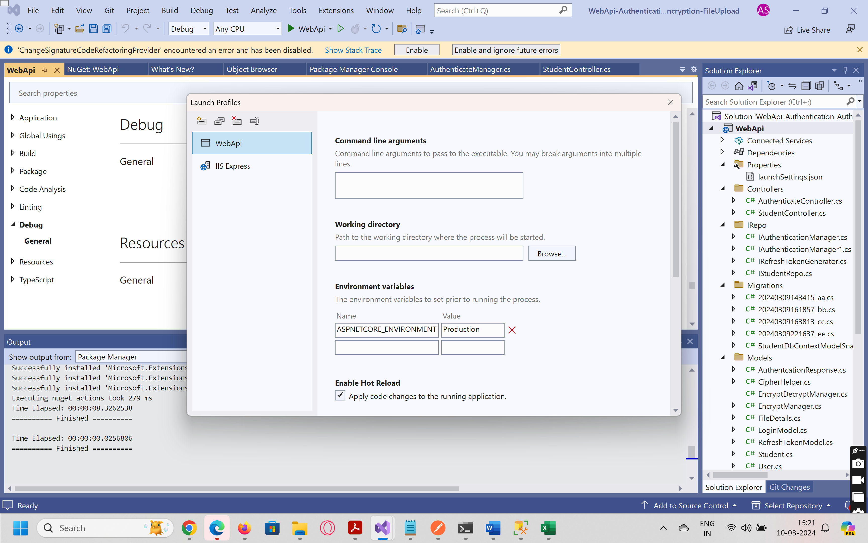

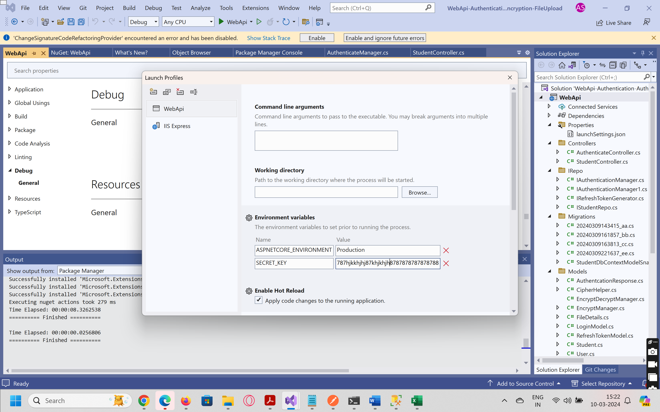

Step 4: Add appSettings.json environment configurations

{

"Logging": {

"LogLevel": {

"Default": "Information",

"Microsoft.AspNetCore": "Warning"

},

"AppSettings": {

"ConnectionStrings": {

"Conn1": "Connectio A with",

"Conn2": "Connectio A with"

},

"IntValue": 5,

"StringValue": "Testing"

}

}

}

Step 5: Add Settings DTO

Step 6: Configure